# LAB II – Introduction to Prolog

## Making a .pl file and consulting.

Make a simple text file and rename it to test.pl.

Write in file

boy(ram).

?- consult(“D:\\prolog\\test.pl").

true.

?- boy(ram).

true.

## First File

Filename : first.pl

boy(ram).

girl(sita).

Terminal

1 ?- consult("D:\\prolog\\first.pl").

2 ?- boy(ram). // According to first.pl, ram is a boy.

true.

3 ?- boy(sita). // According to first.pl, sita is a girl.

**Graph Representation**

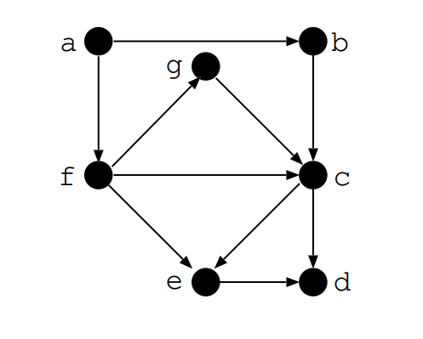

File name: graph.pl

edge(a,b). // ‘a’ is connected to ‘b ‘

edge(a,f).

edge(f,e).

edge(e,d).

edge(b,c).

edge(f,c).

edge(c,e).

edge(f,g).

edge(g,c).

edge(c,d).

path(Node1,Node2):- edge(Node1,Node2).

path(Node1, Node2) :- edge(Node1,Somenode),path(Somenode,Node2). //This is the recursion that checks whether there is path between two nodes which are connected through many edges

1 ?- edge(a,b).

true .

2 ?- edge(X,c).

X = b ;

X = f ;

X = g.

3 ?- path(a,f).

true .

4 ?- path(a,d).

true ;

## Family Representation

File name: family.pl

male(hari).

male(saroj).

female(tirtha).

female(sabina).

parent(hari,saroj).

parent(hari,sabina).

parent(tirtha,saroj).

parent(tirtha,sabina).

father(X,Y):-parent(X,Y), male(X).

mother(X,Y):-parent(X,Y), female(X).

sibling(X,Y):- parent(Z,X),parent(Z,Y),different(X,Y).

different(X,X):- !,fail.

different(X,Y).

## Terminal

?- consult("D:\\prolog\\family.pl").  
true.

?- mother(tirtha, sabina).  
true.

?- father(hari, sabina).  
true.

?- father(hari, saroj).  
true .

?- sibling(saroj, saroj).  
false.

?- sibling(saroj, sabina).  
true .

?- parent(X, saroj).  
X = hari ;  
X = tirtha.

?- sibling(hari, saroj).  
false.